**CURRICULUM VITAE (CV)**

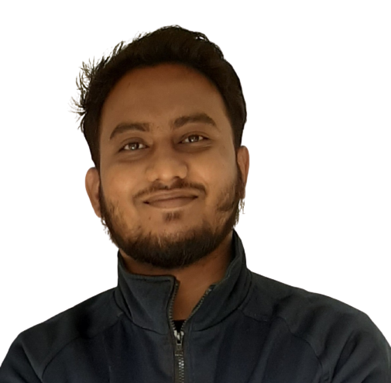

**OF**

**MD. SHAHABUDDIN**

Cell: +88 01740004558

Email: [md.shahabuddin1708@gmail.com](mailto:md.shahabuddin1708@gmail.com)

Website: https://shahabrakib.github.io/md.shahabuddin

**CAREER OBJECTIVE**

To build up a career in a well-established and environment friendly organization where acquired knowledge and expertise can be used effectively and efficiently.

**ADDRESS**

**Present Address:**

Matihar hall, University of Rajshahi, Rajshahi.

**Permanent Address:**

Village: Kale; Post office: Khalilgonj (5600); Subdistrict: Kurigram; District: Kurigram.

**ACADEMIC QUALIFICATION**

|  |  |  |  |  |
| --- | --- | --- | --- | --- |
| Name of Exam | Group/ Subject | Year of Passing | Institute | Result: GPA/ CGPA |
| B. Sc. Fisheries (Hons.) | Fisheries | 2024 | Rajshahi University | 3.25 |
| HSC | Science | 2017 | Rajshahi Collegiate School and College | 4.83 |
| SSC | Science | 2015 | Kurigram Government High School | 5.00 |

**COMPUTER LITERACY**

|  |  |  |
| --- | --- | --- |
| 1. | Operating system | Windows |
| 2. | Word processing | Microsoft word |
| 3. | Spread sheet analysis | MS Excel, MS Access |
| 4. | Presentation | MS Power Point |
| 5. | Others | Audio & Video Editing, Graphic design,Web design and development |

**PERSONAL PROFILE**

|  |  |
| --- | --- |
| Name | Md. Shahabuddin |
| Father’s Name | Md. Salah Uddin |
| Mothers Name | Rabeya Khatun |
| Date of Birth | 17 August 1998 |
| NID | N/A |
| Height | 5’7” |
| Blood Group | A+ |
| Weight | 83 kg |
| Religion | Islam |
| Marital status | Unmarried |
| Nationality | Bangladeshi |

The information stated above is true

Signature